
VERWEY’S SELECTION & TRAINING SERVICES CC
COMPANY REGISTRATION NUMBER: CK 1999/030471/23

18 Villa Luciana
Sunward Park
1470
Gauteng
Mobile: 083-325-9295
Email: vsts@lantic.net

Electronic Winder Logbook
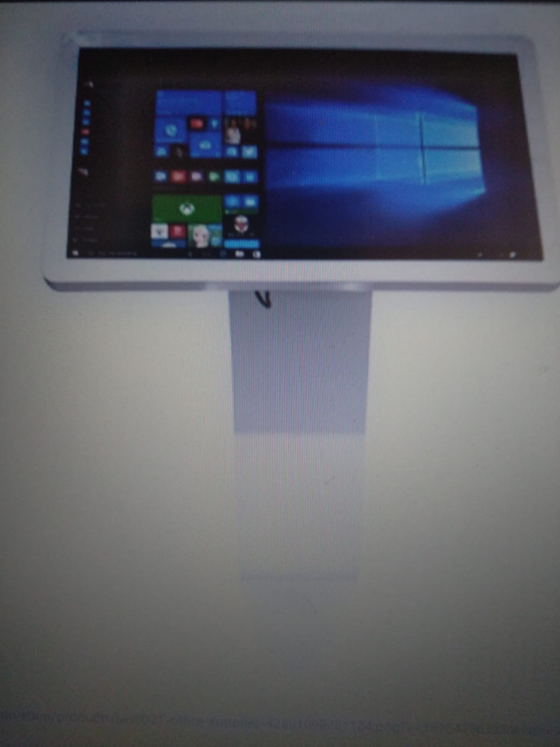



ELECTRONIC SHAFT AND WINDER COMMUNICATION AND DATA LOG

BACKGROUND AND PURPOSE

Being in the mining industry since 1994, it became evident that certain systems, policies, and procedures create room for improvement, i.e., digitalization. Our proposed concept will reduce the use of manual documents and mitigate the risk of human errors, injuries, and/or mechanical breakdowns. This tool could safeguard human capital, property, plant, and equipment from harm and accidents.

This concept is designed to meet end-users’ expectations:

- A specific shaft and winder pairing.
- For specific shafts and winders, operations, and requirements.
- Instant access and availability of information by management and remote communication with shaft and winder operations.
- Limit access to different categories of personnel.
- No person can change or delete an instruction or directive sent or received from any device.
- All documents will be saved on the system on the Winding Engine Driver Footplate or Bank, the hard drive at the Engineers' office, and on the allocated server domain.
- Management can direct and give instructions to shaft and winder personnel remotely and in real-time.
- Promote better communication between shaft workers and winding operations.
- Decrease conflict between shaft workers and the winding operations.
- Assist with planning and execution of shaft and winding operations.
- Assist in planning and scheduling of shaft and Winder maintenance.
- Assist with personnel availability and timekeeping.
- Generating reports, daily, weekly, and monthly.
- Availability of work to be performed, documentation, risk assessment, SOP’s COP’s Regulations, manufacturers specifications.
- Shaft and Winding Personnel can upload photos and video clips as a reference before and after.
- Instant indication of incidents to supervisors and management.
- Automatic, flag notifications to line supervisors and management of delays in scheduled activities, the progress, and/or completion of activities.

Support

- Priority support

Parot 21.5 touch LED Table

It is a versatile and modern interactive display solution designed for a range of professional purposes.

Specifications:
LCD size: 21.5 Classic A HD LCD panel
Light Source: LED Backlight
Resolution: 1920*1080p
Brightness: 300cd/m2
Contrast: 1000:1
Response (Ms): 5ms
Display area: 476.65*268.11
Touch Times: 2,000,000
Viewing angle: 85/85/80/80(L/R/U/D)
Colour: 8bit, 16.7m
Dot pitch: 0.248mm
Main Drive 128G MSATA SSD
Memory: 8G DDR3 1600FSB
Net Card: 100/1000M
Wi-Fi: Built-in 802.11 b/g/n 300Mb/s
Display Core: Intel HD, Display chip, 350/1000MHZ
Sound Card: HD 5.1 hi-fi chip
Interface: 1*VGA, 1*HDMI, 3* USB2.0, 1*USB3.0, 1*RJ-45, 1* Audio
Preloaded OS: Windows 10 OS 64bits Professional

The concept entails the use of an Application Module (App)

Features of the Application Module.

Basic App and Automation Features
- Apps with tablets, galleries, charts, maps, and dashboards
- Add branding, colour themes, and localization
- Capture rich data using forms, checklists, locations, signatures, and photos
- Run apps offline with background synchronisation
- Secure app sign-in via Google, MSFT, Dropbox, Box,
- Manage app users individually and by domain
- Sensitive data management
- Number of databases
- Number of rows per database
- Automate email, SMS, and push notifications
- Google Workspace connectors (Sheets, Forms, Drive, Calendar, Docs)
- Microsoft Excel connectors for Office 365, Dropbox, and Box
- Airable and Smartsheet connectors
- Dynamic emails in Gmail
- PDF document generation
Standard Authentication Providers
- Google
- Microsoft
- Dropbox
- Box
Advanced App and Automation Features

- Barcode scanning and NFC
- Automate data changes and webhooks from app events or on a schedule
- Natural Language Smart Assistant

Application Security Controls

- Manage users by roles and groups
- Security filters
- Dynamic table update modes
- On-device encryption

Machine Learning

- Optical Character Recognition
- Machine learning modelling

Advanced-Data

- Salesforce.com
- Open API
- External services and REST APIs
- Apigee connector
- Big Query connector

Advanced Authentication

- Active Directory
- OpenID Connect
- Okta
- Cognito

Advanced User and Data Management

- App lifecycle management
- Automated error reports
- User activity tracking

Team Collaboration

- Shared data sources
- Shared authentication sources
- Shared connectors
- Centralized billing and shared licenses

Enterprise Data Services

- OData
- Google AI (Doc AI)

Governance & Scale

- Resource allocation for performance
- App Audit Logs
- App Version History
- Restrict who can create apps
- Automated app creator reports and alerts
- Export team audit logs to Big Query
- Transfer apps and databases between team members
- Manage organization and team hierarchy
- Team and organization governance policy enforcement

Basic Layout.

Winding Engine Drivers Logbook Electronic record 0000001
Name of Shaft:
Name of Winder:
Compartments serve:
Date:
Shift:
Duration of the Shift:
Name and Surname of Winding Engine Driver:
Identification information Winding Engine Driver:
Summary of Activity during Winding Engine Driver Shift:
Number of Trips Skips, Conveyance
Break time

Activity performed during Winding Engine Drivers Shift
Logbook and duties
Starting and taking control of a Winding Plant
Demonstrate an understanding of the functions of electrical components on a winder / Winder Examinations During Shift:
Demonstrate an understanding of the functions of Mechanical components on a winder / Winder Examinations During Shift
Winder Maintenance
Demonstrate an understanding of the functions and the operation of signalling arrangements and safety devices in a shaft
Address workplace hazards and risks
Adhere to basic occupational health and safety practices about shaft operations and Emergency procedures.
Operate a direct current winder
Operate an alternating current winder
Operate a friction-driven winder
Operate a Koepe Winder
Operate a Single Drum Winder AC or DC
Position conveyances in a shaft by means of clutching
Load and remove long material into and from a shaft conveyance
Load and remove rolling stock into and from a shaft conveyance
Load and unload persons into and from a shaft conveyance
Sling material into and remove slung material from a shaft
Sling Long / Hafey / piolet material in the shaft
Prepare a conveyance for shaft examination and repairs
Replace a conveyance in a shaft

Auxiliary compressor

Cutting Ropes

New Ropes

New Marks
Shut down a winding plant
Accommodate audience and context needs in oral/signed communication
Interpret and use information from texts
Perform basic firefighting
Carry out basic first aid treatment in the workplace

Basic Layout

Starting and taking control of a Winding Plant

Click on function
Dropbox open

Morning Shift
Afternoon Shift
Night Shift
Emergency Relief

Select Shift

The following sequence of documents open

Regulations pertaining to completing the shift log.
Critical Operational Pressure.
Shift Log

“All documents are sensitive, indicating reading time.”

All functions of the Logbook

Drums
Rope Coiling
Braking System
Gearbox
Winder Motor/s
Control Levers
Depth Indicators
Fittings
Couplings
Cooling Systems
Winding Engine Drivers Limits and Brake Test
Safety Devices
Communication Systems
Grads and Fences
Lighting Systems
Backup Electrical and Hydraulic systems
Notifications and Notice Board
Fire Suppression Systems
House Keeping
Security

Drums

Click on function
Dropbox open

Overlay Drum | Drum Flange
 | Drum Fittings
 | Numbers Indicators
 | Rope Connections
 | House Keeping
Underlay Drum | Drum Flange
 | Drum Fittings
 | Numbers Indicators
 | Rope Connections

Click on function
Dropbox open

Overlay Drum | Drum Flange | Red | Orange | Green

Click on function
Dropbox open

Overlay Drum | Drum Fittings | Red | Orange | Green

Click on function
Dropbox open

Overlay Drum | Numbers Indicators | Red | Orange | Green

Click on function
Dropbox open

Overlay Drum | Rope Connections | Drum Fittings | Red | Orange | Green

Click on function
Dropbox open

Overlay Drum | House Keeping | Drum Fittings | Red | Orange | Green

Click on function
Dropbox open

Underlay Drum | Drum Flange | Red | Orange | Green

Click on function
Dropbox open

Underlay Drum | Drum Fittings | Red | Orange | Green

Click on function
Dropbox open

Underlay Drum | Numbers Indicators | Red | Orange | Green

Click on function
Dropbox open

Underlay Drum | Rope Connections | Drum Fittings | Red | Orange | Green

Click on function
Dropbox open

Underlay Drum | House Keeping | Drum Fittings | Red | Orange | Green

Comments

Winder Maintenance

All artisans will be flagged daily on their mobile devices 45 minutes before the procedure starts.
The foreman will receive a flag if the procedure does not start on time after a set period.
Thereafter the Engineer and then Senior Management.
The system will generate reports on the condition of the equipment, activities, maintenance, and delays daily, weekly, monthly, and quarterly.

Click on function
Dropbox open

Morning Shift
Afternoon Shift
Night Shift

Select Shift

The following sequence of documents open

Regulations pertaining to completing the shift log
Critical Operational Pressure
Risk assessment
Shift Log

“All documents are sensitive, indicating reading time.”

Morning Shift

Click on function
Dropbox open

Daily
Weekly
Monthly
Three Monthly
Six Monthly
Yearly
Maintenance
Emergency

Only the legally appointed artisan will have access to the system to operate.
The artisan will not have access to the system if the winding engine driver does not access the system first.
Only after all relevant supporting documents have been completed will artisans have access.

- Have you done your Risk Assessment?
- Record that the examination is about to begin in the driver’s logbook – enter the time and ensure that the driver countersigns the entry.
- Observe all safety procedures and wear safety protection.
- Observe any special instructions.
- Always ensure that loose clothing and body parts are clear from gears, couplings, and moving parts.
- Do not operate the machine in an unsafe condition, unless to repair an unsafe condition.
- Ensure the machine is isolated and locked out before working on the machine.
- Scrutinize the driver’s logbook for any adverse conditions recorded by the drivers for the last 24 hours.
- At the end of the examination clear the driver’s logbook (enter time), and the driver to countersign.
- Record any faults and actions taken in the driver’s logbook and the machinery record book.
- At the end of the examination, clear the driver’s logbook (enter time), and ask the driver to countersign.

Daily

Click on function
Dropbox open

Electrician
Fitter
Boilermaker
Rigger
Forman
Engineer

The system will confirm that the daily examination was done, on time and will send a report to the relevant personnel.

